**FOR MORE INFORMATION:**Sara Barksdale / Sarah Wynn Benton  
BRAVE Public Relations  
404.233.3993  
[sbarksdale@emailbrave.com](mailto:sbarksdale@emailbrave.com) / [sbenton@emailbrave.com](mailto:sbenton@emailbrave.com)

**FOR IMMEDIATE RELEASE**

**Fox Gives Receives 2024 Georgia Cities Foundation Legacy Partner Award**

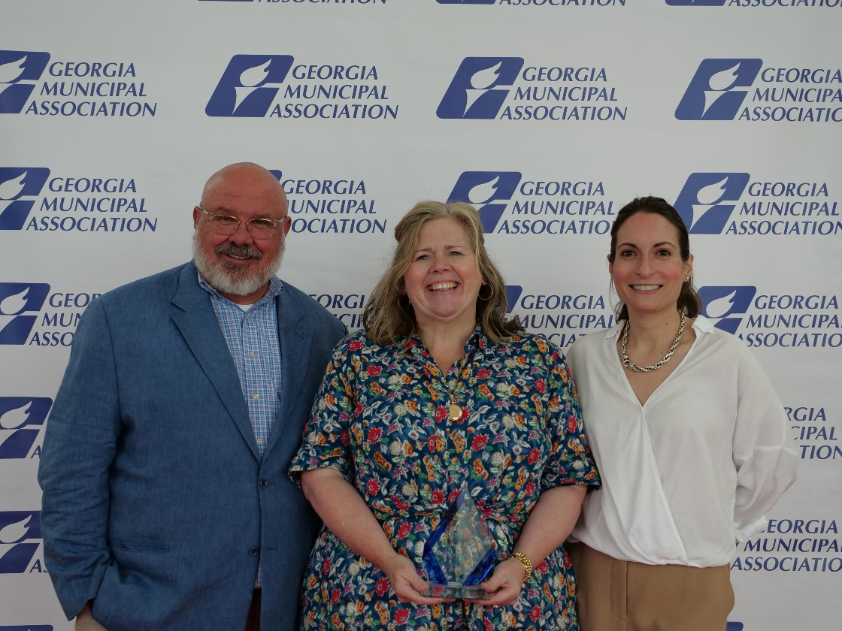

*Left to Right: Jamie Vosmeier, Vice President of Sales and Marketing; Leigh Burns, Director of Community Partnerships; Aly Grubb, Director of Sales and Marketing  
Link to images:* [*here*](https://drive.google.com/drive/folders/19AWzHZY-lkhEXebF1jyM4lcUrxEXrAbz?usp=sharing)

*Link to video:* [*here*](https://www.youtube.com/watch?v=Ewfu_lOeiWY)

**ATLANTA (June 28, 2024)** – Fox Gives is proud to announce it has received The Georgia Cities Foundation's (GCF) 2024 Foundation Legacy Partner Award. This award honors outstanding long-term commitment and partnership in urban redevelopment and community enhancement, recognizing the significant contributions made by Fox Gives over the years.

The Legacy Partner Award celebrates cities or organizations that have demonstrated enduring dedication to community improvement, economic development, and fostering strong partnerships. The Georgia Cities Foundation selected Fox Gives for its sustained and impactful initiatives, including the Fox Gives grants program. This program provides sizable grants to historic theatres in regions of the state needing urgent or emergency repairs, such as those suffered during floods or fires, as well as their efforts in offering high school students front-row access to entertainment industry careers – from lighting and sound to stage and venue management. These efforts have resulted in compassionate community outreach initiatives that provide good fortune and benefit to many across the state.

“Our entire Fox Theatre organization is thrilled to receive the inaugural 2024 Legacy Partner award from the Georgia Cities Foundation,” said Leigh Burns, Director of Community Partnerships at Fox Gives. “Receiving this inaugural award from a group of our peers who are dedicated to enhancing the vitality of Georgia's cities is truly a humbling recognition. This honor further motivates our dedication to fostering community and economic development across the state through the preservation of arts and culture.”

The Georgia Municipal Association presented Fox Gives with the award at its annual awards ceremony on Monday, June 24, at the Savannah Convention Center. The ceremony brought together leaders from across the state to celebrate cities' achievements and recognize their contributions to building a better Georgia.

“Fox Gives exemplifies the spirit of the Legacy Partner Award through their unwavering commitment to community development,” said Pam Sessions, President of the Georgia Cities Foundation. “Their long-term vision and collaborative approach have created lasting benefits for those they partner with and serve as a model for other organizations. GCF and the Georgia Municipal Association are grateful for Fox Gives' support of Georgia's cities.”

For more information about the Georgia Cities Foundation and the Renaissance Award, please visit [www.georgiacitiesfoundation.org](http://www.georgiacitiesfoundation.org).

###

**About the Georgia Cities Foundation:**  
The Georgia Cities Foundation is a nonprofit organization dedicated to helping cities across Georgia achieve their goals of economic development, urban revitalization, and community improvement. Through various programs, grants, and initiatives, the Foundation supports cities in creating vibrant, sustainable, and resilient communities.

**About the Fox Theatre**  
The Fox Theatre is one of Atlanta's premier venues for live entertainment, welcoming more than 150 performances a year in its 4,665-seat theatre. From concerts to ballets, comedy, and movies, the historic venue attracts more than 500,000 visitors annually. The theatre hosts over 100 annual private events like wedding receptions, trade shows, corporate meetings, and association functions in two fabulous ballrooms. The Fox’s premium Marquee Club, presented by Lexus, is a 10,000 sq. ft., three-story luxury bar accessible to all Club Level ticket holders or annual members of the Fox Theatre. As a 501(c)(3) nonprofit arts organization, the Fox Theatre is a fiercely protected landmark and nationally acclaimed theatre today. The Fox Theatre proudly acknowledges its partners' generous support: Casamigos, Coca-Cola, Georgia Natural Gas, Georgian Terrace Hotel & Livingston Restaurant, Humana, Lexus, Northside Hospital and Regions Bank. Tickets for all events are available at [FoxTheatre.org](https://protect-us.mimecast.com/s/v0QXCOYoRKcNvKACmEBXS?domain=secure-web.cisco.com), or toll-free at 855-285-8499.  Stay connected by following the Fox Theatre on social via @theFoxTheatre on [Instagram](https://protect-us.mimecast.com/s/SE2wCPNp8Li03x4HxEXzY?domain=secure-web.cisco.com), [Twitter](https://protect-us.mimecast.com/s/6oQPCQWqRMHXoW6i7XoPc?domain=secure-web.cisco.com) and [Facebook](https://protect-us.mimecast.com/s/kDgUCR6r7NtG5LrIZrWlF?domain=secure-web.cisco.com).

**About Fox Gives**Fox Gives is the expanded outreach arm of Atlanta's iconic Fox Theatre, committed to fostering community partnerships and enriching lives through the arts. Evolved from the Fox Theatre Institute, Fox Gives continues the legacy of providing historic preservation expertise, consultation, and education to performing arts venues in Georgia and beyond. With a focus on environmental and economic impact, Fox Gives offers multiyear preservation grants, arts education programs, and vocational mentorship, leveraging resources to stimulate local economies and keep the artistic pulse of communities vibrant. Under the Fox Gives umbrella, the theatre introduces transformative initiatives like the All-Access Pass high school program to open new doors in vocational arts education for young minds. For more information, visit [foxtheatre.org/foxgives](http://www.foxtheatre.org/foxgives) and stay connected on [Facebook](http://www.facebook.com/foxgives_atl) and [Instagram](http://www.instagram.com/foxgives_atl).